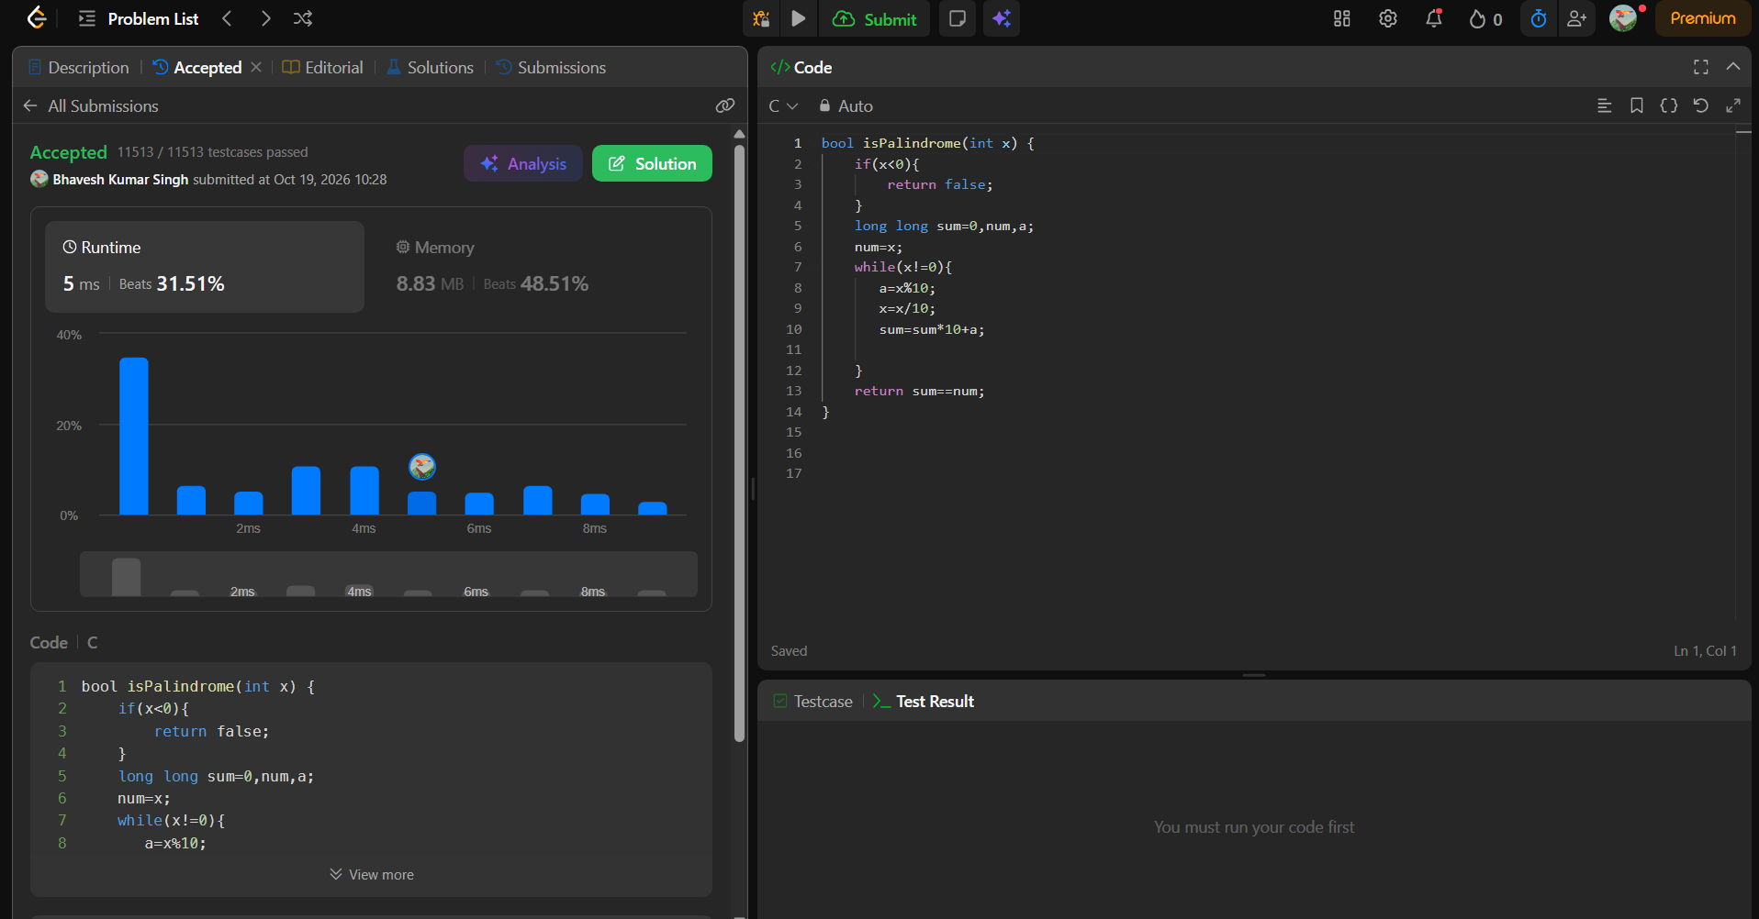
bool isPalindrome(int x) {
if(x<0){
return false;
}
long long sum=0,num,a;
num=x;
while(x!=0){
a=x%10;
x=x/10;
sum=sum*10+a;

}
return sum==num;
}

